Riana Zuchlewski

Professor Nguyen

CIS 18A

Project Documentation

1. Select a business type- I chose to select the Coffee Shop business type.
2. Company Name- I chose to have fun with the name and choose a pun of Brew-tiful Coffee.
3. My Pseudocode went a little like this:

* Display menu for operator
* Display order line for operator
* Insert loop for total order
* Declare variables, strings, and arrays needed
* Insert scan to remember order
* Switch cases
* Display total and Items

1. Documentation:

The code I am submitting is to be used in the coffee shop. It is preferably going to be used by the baristas and store operators. It’s purpose is to create a cheap way of creating a point of sale operator without the fancy computer software. I want it to be something where somebody who is not tech savy or coding savy can go in and edit things to their own restaurant/business. Its business function is to be a clear and simple way for a cashier or operator to see the menu and press the according number it is helpful in a business by allowing a new employee or somebody who is not familiar with the menu by showing them a personal copy of what they are selling. The technical aspect is to have the program account for the item, price, and final total for the operator. It is supposed to make the user not have to touch a calculator or struggle to remember the order of the customer.



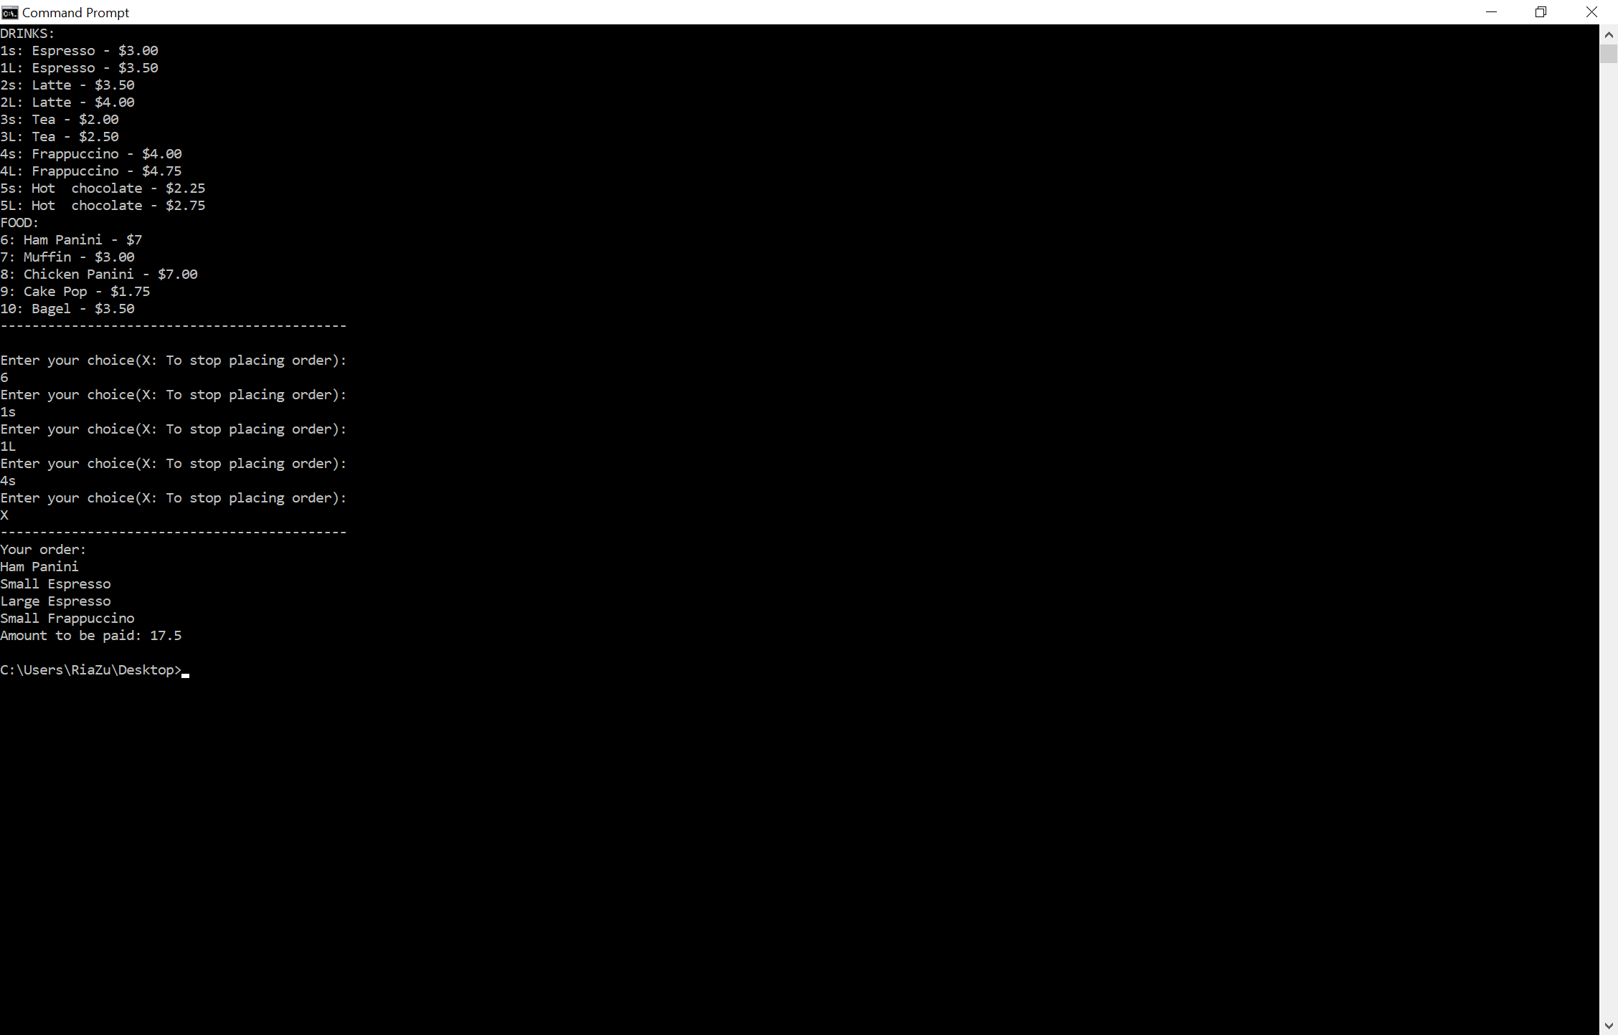

Flow Chart:



MENU DISPLAY

ORDER Screen-

1 item only

2 items only

3 items only

4 items

5 items

TOTAL:

Items Ordered: